Building Your Own Country
Webquest Workbook
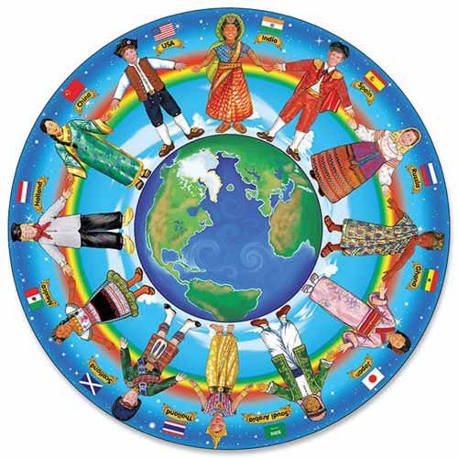

Group Names :
_____________________________________________________

____________________________________________________

____________________________________________________

____________________________________________________

How to Start Your Own Country

Define micronation : ____a country which has been "declared" independent by individuals or small groups_______________________________________________________________________________

What is the world’s smallest nation called? ____The Principality of Sealand_________________

1 A: Name Your Country

How did Bolivia get its name? ___It was named after Simon Bolivar in 1825 because he

led the struggle for independence! ____________________________________________________

_______________________________________________________________________________________

List three of your favorite country names from the map!

- _____________________________________

- _____________________________________

- _____________________________________

You’ve decided to name your country…….

______________Name_____________

1 B: Design a Flag

List three similarities you see between all of the flags:

- _____________________________________

- _____________________________________

- _____________________________________

List three differences you see:

- _____________________________________

- _____________________________________

- _____________________________________

Have the National Artist draw your flag!

1 C: Choose a Motto

List three of your favorite national mottos from the list!

- _____________________________________

- _____________________________________

- _____________________________________

What is America’s national motto? __________In God We Trust________________________

What is YOUR country’s national motto? _____________________________________________

1 D: National Anthem

What is the title of America’s national anthem? ________The Star-Spangled Banner__________

Write a national anthem for YOUR country! Just fill in the blanks!

(sing to the tune of “Old MacDonald had a farm”)

“ Hail ____________________ , ____________________ and true. We stand tall for you!
Name of Country adjective

A micronation that’s brand new. Home to just a few.

With some ____________________ here and some ____________________ there.
Plural Noun Plural Noun

Here a _______________ there a ________________, everywhere a _______________ ______________ .
Noun Noun Adjective Noun

Hail ____________________ , ____________________ and true.
Name of Country Adjective

We ____________________ and ____________________ for you! ”
Verb Verb
2 A: Set Up Your Government
Take some notes on the differences between the 4 types of government you’ve researched
Oligarchy | Monarchy | Democracy | Republic

What type of government would you like to run your nation? Why?
________________________________________________________________________________
________________________________________________________________________________
________________________________________________________________________________
________________________________________________________________________________
________________________________________________________________________________
2 B: Write a Constitution

Fill in the Blanks about the U.S. Constitution:

1. The writers of our Constitution wanted to make sure that the new nation and its

citizens would be _______free________ and _____independent____ .

2. Each state would be given _____one_____ vote(s).

3. ____35_____ (#) delegates were present during the writing of the Constitution.

Write a Constitution that is right for YOUR country!
____________________________________________________________________________________________
____________________________________________________________________________________________
____________________________________________________________________________________________
____________________________________________________________________________________________
____________________________________________________________________________________________
____________________________________________________________________________________________
____________________________________________________________________________________________
____________________________________________________________________________________________
____________________________________________________________________________________________
____________________________________________________________________________________________
____________________________________________________________________________________________
____________________________________________________________________________________________
____________________________________________________________________________________________
____________________________________________________________________________________________
____________________________________________________________________________________________

List 5 laws for your country (2 can be silly!) :

- _____________________________________

- _____________________________________

- _____________________________________

- _____________________________________

- _____________________________________

2 C: Make Some Money

Fill in the Blanks!
- Usually, people or civilizations trade things that they have ________ _________ ______ for things that they don't have enough of.

- When you have too much of something, you can save____ it, store___ it, or sell___ it.

- Often, trade involves many civilizations at the same time.

- Peoples and countries and civilizations need to trade because they can't __produce___ by themselves everything they need to ___survive___.

- You can buy and sell just about anything over the ____Internet___.

- __Computers__ are constantly changing the way people do business in very exciting ways.

What good(s) does your country have too much of that you think you would like to trade

with other countries? ____________________________________________________________________

Have your National Treasurer draw the money of your country!

Remember: Every coin or bill that the government makes has the year it was made stamped
or printed on it.

